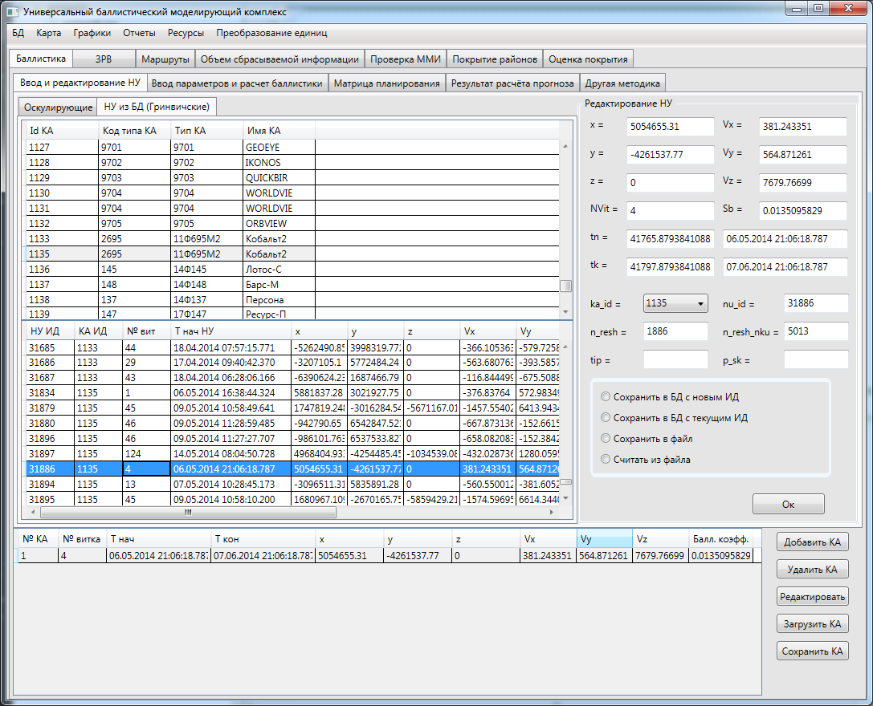

|  |  |  |  |  |  |  |  |  |  |  |
| --- | --- | --- | --- | --- | --- | --- | --- | --- | --- | --- |
| 1 | 4 | 06.05.2014 21:06:18.787 | 07.06.2014 21:06:18.787 | 5054655.31 | -4261537.77 | 0 | 381.243351 | 564.871261 | 7679.76699 | 0.0135095829 |

Ka_id 1135 **nu_id 31886** n_resh 1886 n_resh_nku 5013